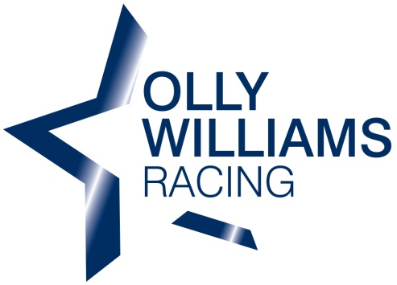
Stone Stables
Nettleton Top
Market Rasen
Lincolnshire
LN7 6SY

07793 111600

Types of Ownership

There are several different types of ownership making owning a racehorse with us very affordable for everyone.

There are lots of different types of horses within horseracing, wether it’s a two year old sprinter or six year old National Hunt three mile chaser, we can cater for you. We are always happy to help an owner find the horse for them.

Sole Ownership

Sole ownership is when you fully own the horse. You are responsible for all costs and profits. Through this type of ownership your horse will run in your colours and you will be closely involved in decisions on where and when your horse runs and who rides it. You will also be able to name the horse if not already named.

Co-Ownership

This type of ownership involves more than one person. There are four different types of co-ownership listed below:

1. Joint Ownership

Joint Ownership can consist of between 2 and 12 people. The horse can be run in the name of the joint ownership or the names of the individuals.

2. Company Ownership

Company ownership is when the company acts as the sole owner of the horse but shareholders in the company can participate through their shareholdings. It can be a great way of advertising your company and if you desire, your horse can be sponsored by your company.

3. Racing Partnership

Racing Partnerships can consist of between 2 and 20 people of which at least two must become, or perhaps already are, registered owners with Weatherbys. We will be setting up a racing partnership in the future or alternatively one of the partners may wish to do this their selves.

4. Leasing

Leasing a horse can be a very cost effective way of owning a racehorse. Leasing a horse any where from one race to the whole season or even its entire racing career, can easily be arranged. The owner would pay all costs for the horse during the contract.

Racing Clubs

Racing clubs have become very popular over recent years. They are a very cost effective way of owning a racehorse with one off payments without any hidden costs. By becoming a member of a racing club you can enjoy all the benefits of that club but you are not entering in racehorse ownership yourself.

